**Ideation Phase**

**Define the Problem Statements**

|  |  |
| --- | --- |
| Date | 24 September 2022 |
| Team ID | PNT2022TMID33879 |
| Project Name | A novel method for handwritten digit recognition system using Artificial intelligence |
| Maximum Marks | 2 Marks |

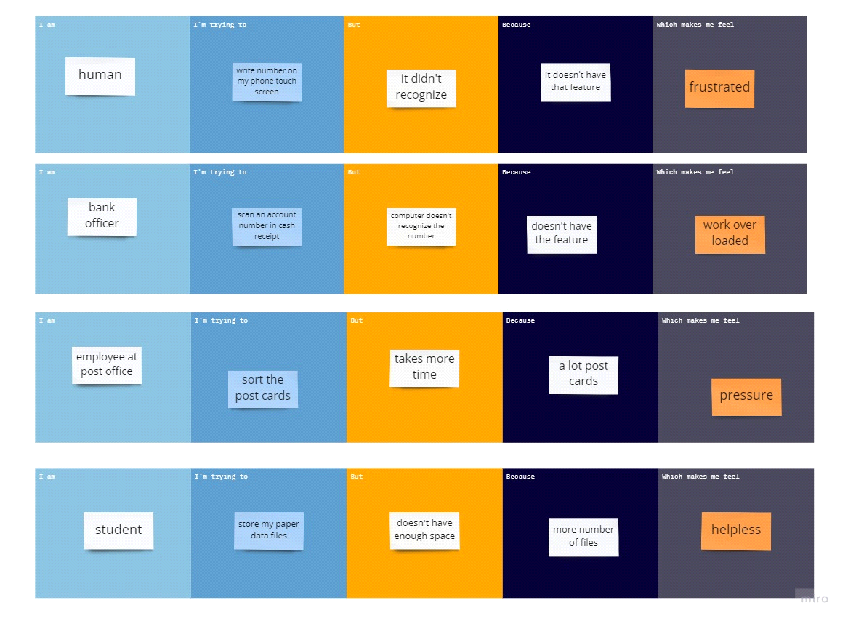

**TEAM ID:** PNT2022TMID33879

**TEAM LEADER: Pradeep Raj**

**TEAM MEMBER: Praveen Kumar**

**TEAM MEMBER: Sheshayee**

**TEAM MEMBER: Sameerul Anwar**